Airline Dataset

**I. Data preprocessing 2**

**1. Python 2**

**2. Table added 4**

**II. Findings 8**

**1.Overview 8**

**1.1 Region Overview 8**

**1.2 The competitiveness in the industry 10**

**2. The West 12**

**2.1 West’s overview 12**

**2.2 Competitiveness in the West 13**

**2.3 What can newcomers do in the west 14**

**Recommendations for new brand in the west : 15**

**3. Other region (SE/SW/MW/NE) 17**

**3.1 Region Market Dynamics 17**

**3.2 Rookie Success Stories: 18**

**3.4 Passenger Growth Hotspots: 21**

**3.5 Passenger growth in detail : 22**

**3.6 Decline in Virgin Islands Travel: 24**

**Recommendations Airlines and Tourism company: 25**

**4. Expressjet airline’s problem (EV) 26**

**4.1 Rapid Growth and Sudden Decline in Total Flights: 26**

**4.2 Average Delay Time Increases Due to Carrier-Related Issues: 26**

**4.3 Increased in cancellation and their causes 27**

**4.4 Fleet Management Challenges: 29**

**4.5 Shift in Key Flight Paths: 30**

**Recommendation Expressjet Airlines: 32**

# I. Data preprocessing

## Python

## 

## 

## 

## 

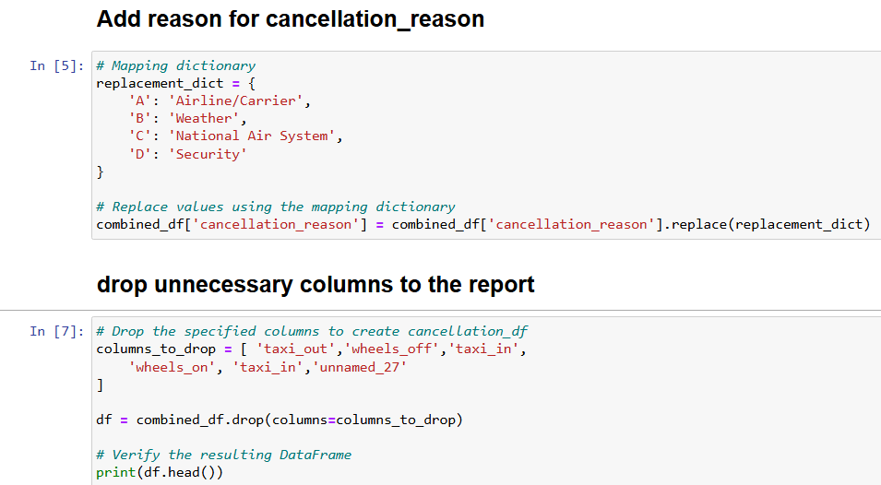

## 

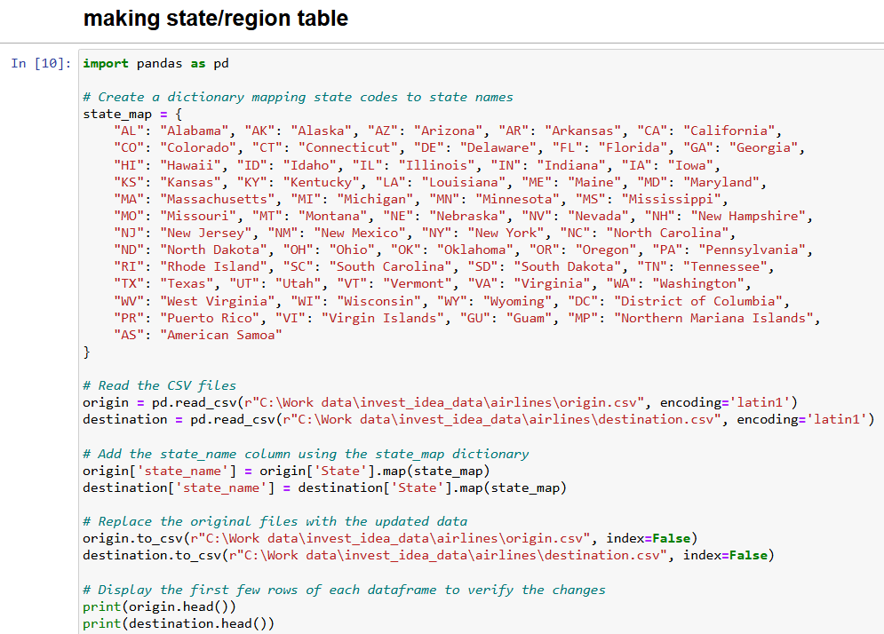

## 

## 

## 

## 

## 

## 

## 

## 

## 

## 

## 

## 

## 

## 2. Table added

## 

## 

## 

## 

Breaking USA into 5 region  
- A region is an area of land that has common features. A common way of referring to regions in the United States is grouping them into 5 regions according to their geographic position on the continent: the Northeast, Southwest, West, Southeast, and Midwest.

NE - Northeast :

States: Connecticut, Maine, Massachusetts, New Hampshire, New Jersey, New York, Pennsylvania, Rhode Island, Vermont

* Have multiple major financial centers like New York or Boston
* High levels of urbanization

SW - Southwest :

States: Arizona, New Mexico, Oklahoma, Texas

* Having a smaller population and lower financial status than others.
* Festivals: Rich in cultural festivals and events celebrating Hispanic heritage.

WE - West :

States: Alaska, California, Colorado, Hawaii, Idaho, Montana, Nevada, Oregon, Utah, Washington, Wyoming

* Including mountains, forests, deserts, and coastline.
* Strong emphasis on outdoor activities like hiking, skiing, and surfing
* Known for technological innovation and the presence of major tech companies (especially in California's Silicon Valley).

SE - Southeast :

States: Alabama, Arkansas, Florida, Georgia, Kentucky, Louisiana, Mississippi, North Carolina, South Carolina, Tennessee, Virginia, West Virginia

* Known for hospitality, friendliness, and a slower pace of life.
* Climate: Generally warm climate with hot summers and mild winters.

MW - Midwest :

States: Illinois, Indiana, Iowa, Kansas, Michigan, Minnesota, Missouri, Nebraska, North Dakota, Ohio, South Dakota, Wisconsin.

* Strong manufacturing and agricultural sectors.

Brand table :

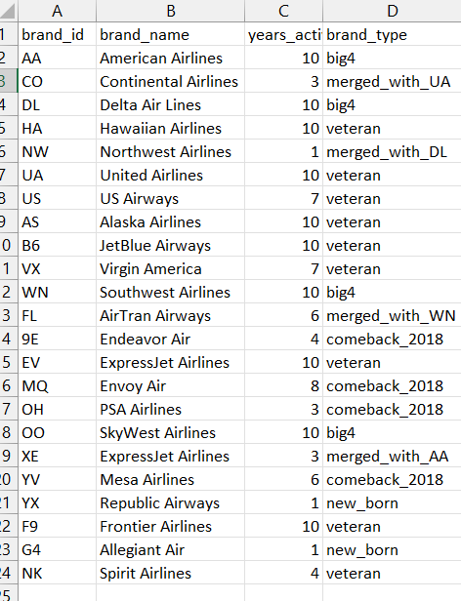

1. Big 4 consist of 4 biggest airline brand based on total amount of flights

* AA - American Airlines ~10%, DL - Delta Air Lines ~ 10%,  
  WN - Southwest airlines ~ 20%, OO - Skywest airlines ~ 10%

2. Veteran brand - brand with 10 years of active

* AS, F9, EV, VX, B6, NK, US, UA, HA

3. Brand that used to active in the past but suddenly not active anymore until 2018

* 9E, MQ, YV, OH,

4. Brand that born in 2018

* YX and G4

# II. Findings

## 1.Overview

### **1.1 Region Overview**

Observation : From 2009 to 2018, the U.S. can be divided into five main regions with a total of approximately 61.56 million flights. The Southwest and West regions are the largest contributors, each accounting for around 17 million flights. The Midwest, Northeast, and Southeast follow in terms of flight volume.

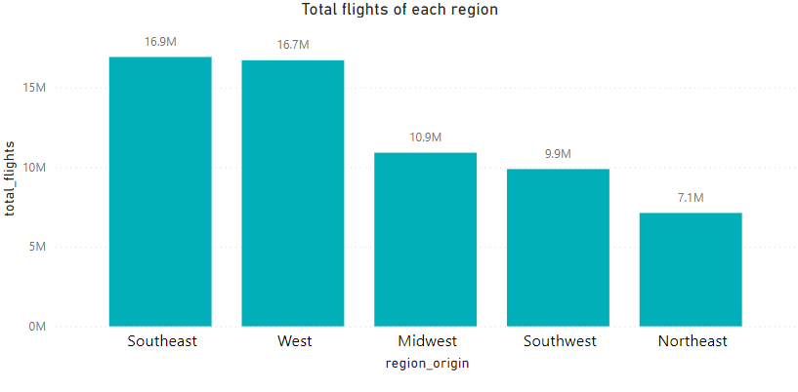

Within these regions, key states include:

* Midwest: Illinois, Minnesota, Michigan
* Northeast: New York, Massachusetts, New Jersey, Pennsylvania
* Southeast: Georgia, Florida, North Carolina
* Southwest: Texas, Arizona
* West: California, Colorado, Nevada  
    
    
    
    
    
    
    
    
    
    
  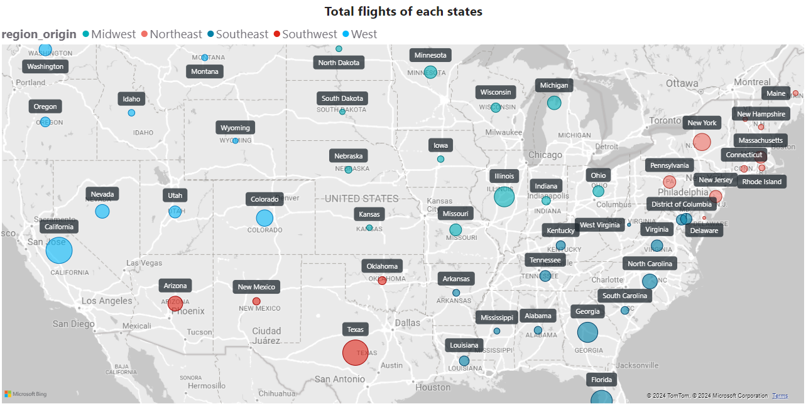
* In 2018, there was a noticeable uptrend in flight activity for all regions except the West. The Southeast region particularly drove this trend, with passenger numbers rising from 1.5 million in 2017 to 2.1 million in 2018.

### 

### **1.2 The competitiveness in the industry**

Observation : The demand in the airline industry has taken a big step forward in total flights from 5.7 million in 2017 to 7.2 million in 2018 compared to the previous period from 2009 to 2017 where the amount of flights have been decreasing steadily from 6.4 million to 5.7 million.   
- Similar to the total flights, even though the amount of brands have been falling from 19 brands in 2009 to 12 brands in 2017 .With the increase in demand, the amount of brands competing in the industry also increased from 12 brands to 18 brands.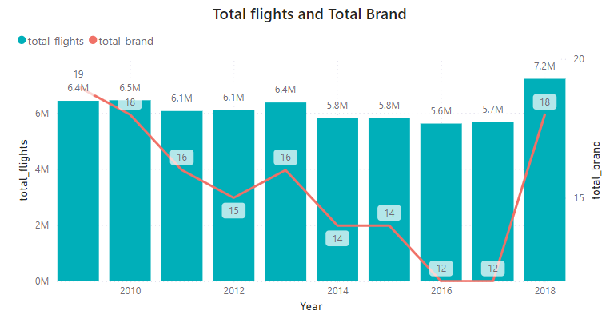

* The competitiveness in the industry is evident as 30% of the brands (6 out of 18) capture 70% of the total flight market share, indicating that the market is highly competitive. Each airline risks losing ground to others if they fail to optimize their strategies accordingly.  
  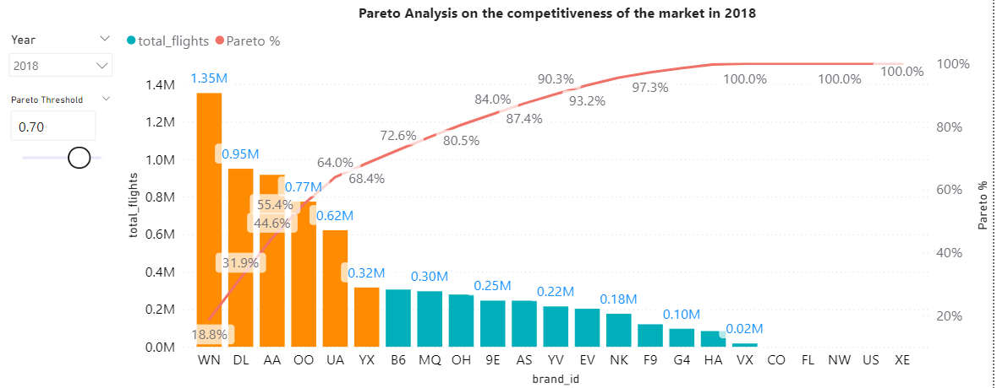
* In those 6 brands that engaged the market in 2018, they are including 4 brands that inactive in recent years and 2 new brands. 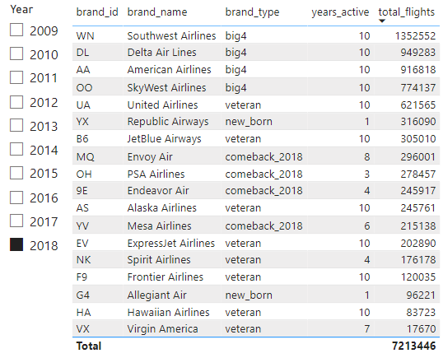

Insight : The market is highly competitive and with the embracing of newcomers and some even have a good performance already like the Republic Airways (YX) or Envoy Air (MQ) so there could be more brands to come in the upcoming year.

## 2. The West

### **2.1 West’s overview**

Observation :

Local Flight Dominance: Up to 63% of flights from the West are local, indicating a strong preference for travel within nearby states.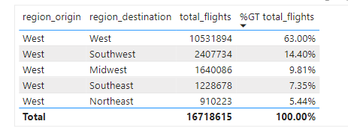

Key States: California, Colorado, and Nevada are the primary departure points, with California accounting for 44% of all West-originating flights. This trend persisted through 2018.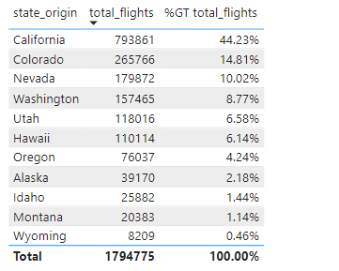

Popular Local Routes: The most frequent route is California → California (13%), making it the most popular flight path in the country. Other significant routes include California → Texas (3.67%), Hawaii → Hawaii (3.67%), and California → Arizona, Nevada, and Washington.

Destination Patterns: 60% of the West's flights are destined for other states within the West. When traveling outside the West, passengers often head to Texas or Arizona (33% combined, both in the Southwest), and 10% fly to Illinois (Midwest).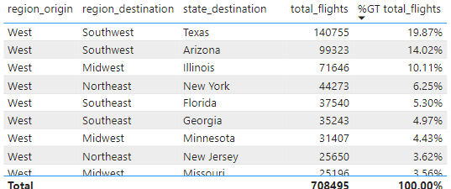

Insight : The West region, being a major tourist destination with diverse attractions like San Francisco, LA, Las Vegas, and others, drives a strong tendency for local travel. Residents and tourists alike prefer short-haul flights within the region, reducing the need to travel further afield. People from the west also prefer to fly to certain States outside the West.

### **2.2 Competitiveness in the West**

Observation : 97% of flights in the West are operated by big 4/veteran brands, with newcomers capturing only 3% of the market. The most successful brands are Southwest Airlines (WN) with 25%, SkyWest Airlines (OO) with 17%, and United Airlines (UA) with 13%.

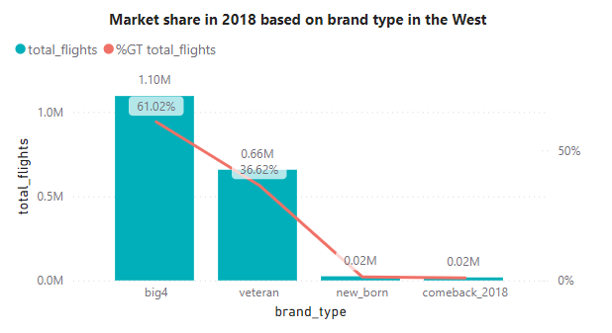

Insight : The dominance of established brands suggests that West region customers may prioritize familiarity and experience over trying new airlines. The local flight dominance could make it less appealing for newcomers to enter the market, as the limited diversity of flight paths intensifies competition.

### **2.3 What can newcomers do in the west**

Observation : Southwest Airlines (WN) has a significantly larger fleet, allowing for lower flights per aircraft while maintaining a high total number of flights. WN operates each aircraft for up to 10 flights per month, while other big brands push up to 20 flights per aircraft.

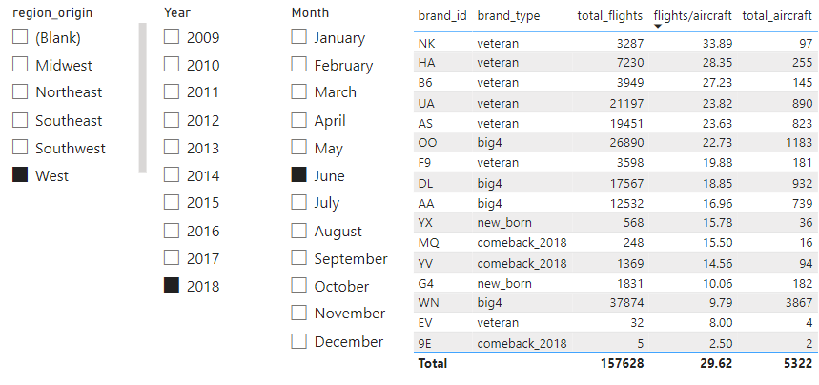

Insight : Many brands might suffer from this since they have less aircraft than they should, having more aircraft when the total flight is high also reduces the chance for delay/cancellation of flights because of reasons related to the carrier. Having more aircraft also let them schedule for more fly path → increase total flights

### Recommendations for new brand in the west :

**West Market Dynamics:** The relatively stable flight numbers in the West may stem from its high proportion of local flights. As a result, there's limited room for growth in long-haul travel within the region.

Next Step :   
+ Finding the reason why West’s people choose local flights by conducting surveys. Knowing the reason for it will contribute to customer understanding.

**Newcomer Strategies:** If they have certain aircraft that are always ready to carry flight in the West, they should consider leasing their inactive aircraft to established brands that may be overstretched. This strategy would optimize fleet usage, reduce idle costs, and mitigate the risks associated with underused planes, such as mechanical degradation. Given that West’s local flights are typically short, this could further reduce wear and tear on the aircraft, making it a win-win for both parties.

If not, they can try to schedule more flights in other regions.

Next Step : Newcomers should have the data about :

* Number of their inactive aircraft/month in the West
* Finding the cost of inactive aircraft : (fixed cost like maintenance, variable cost like opportunity profit that each inactive airline can bring)
* Knowing more about the demand of bigger brand, if they need aircraft to schedule more flight ⇒ find out about their fee, compares to the cost to know the profit opportunity
* Conduct social experiments to know about what people in the West really think about inexperienced brands and their chances here and why?

## 3. Other region (SE/SW/MW/NE)

### **3.1 Region Market Dynamics**

Observation: Newcomers have varying levels of success depending on the region. In the Northeast, new brands managed to capture 12% of the market, while other regions saw newcomers taking 21% to 30% of the market share. The West appears to be the most challenging region for new entrants. 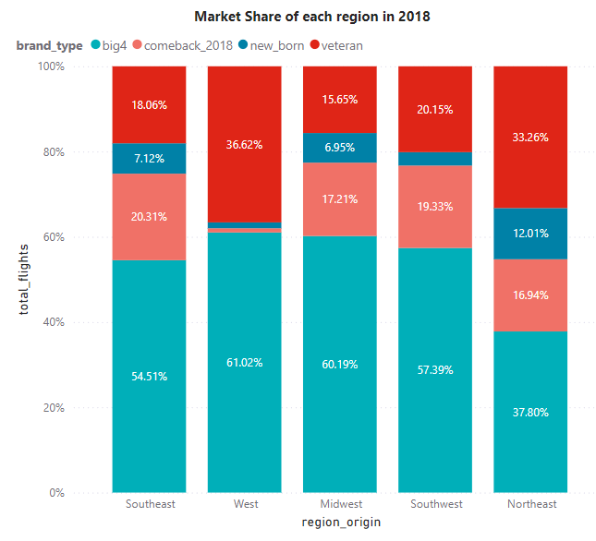

Insight: The variation in market share suggests that regional factors, such as consumer loyalty, competition, and market saturation, play a significant role in the success of new airlines. The West's established brand loyalty and possibly more saturated market make it difficult for new brands to penetrate.

### **3.2 Rookie Success Stories:**

Observation: Certain new or returning brands, dubbed "rookies of the year" managed to outperform even established brands in their respective regions. These brands including : 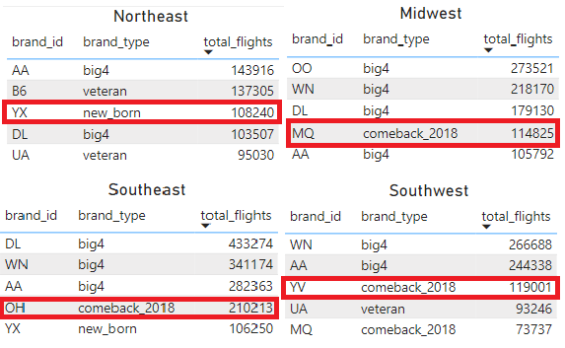

* YX - Republic Airways in the Northeast
* MQ - Envoy Air in the Midwest
* OH - PSA Airlines in the Southeast
* YV - Mesa Airlines in the Southwest.

Insight: These rookie brands excelled in only 1 - 2 regions, suggesting that they concentrated their efforts on a particular area rather than spreading their resources too thin. This regional focus highlights the importance of understanding and catering to local market dynamics. It also suggests that even new or smaller airlines can compete effectively with larger, established players if they focus on a specific region and tailor their strategies accordingly. **Recommendations** for new and upcoming brand **:**

* Conducting surveys of people from different regions can help us understand their opinion, the reason why they choose newbrand. Especially people from Northeast

+ Analyzing Rookie strategies (Marketing, Flight schedule) in their favorite region to know how they surpass even big brands.

+ Focusing on a single to maximum two regions where they can build a strong presence before expanding.

+ Conduct in-depth research on the marketing, social media presence, and unique value propositions of these successful rookie brands.

**3.3 Regional travel patterns :**

Observation : Compared to the West, other regions have more diversified travel paths but a significant portion of flights remain within the region. However, in the Northeast, a notable 44% of flights are directed towards the Southeast, and only 15% remain within the Northeast.

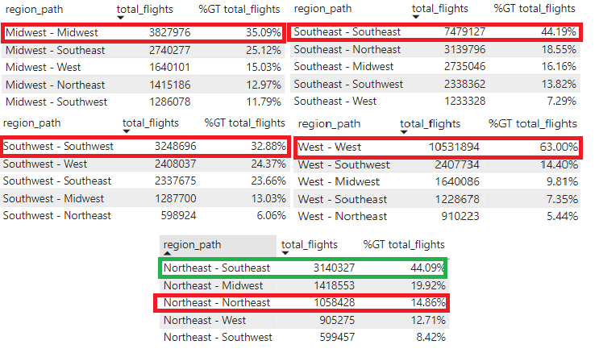

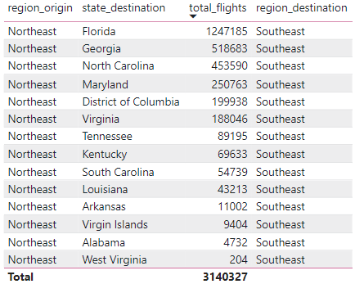

The main destinations in Southeast that Northeast fly to are - Florida, Georgia, NoCarolinarth .

Insight: The Northeast's tendency to travel outside the region suggests a higher level of connectivity and interaction with other regions, particularly the Southeast.

### **3.4 Passenger Growth Hotspots:**

Observation: From 2017 to 2018, certain states experienced significant passenger growth, particularly Texas, North Carolina, New York, Florida, and Illinois. Additionally, states like West Virginia, Vermont, Kentucky, and others saw substantial growth compared to their previous numbers.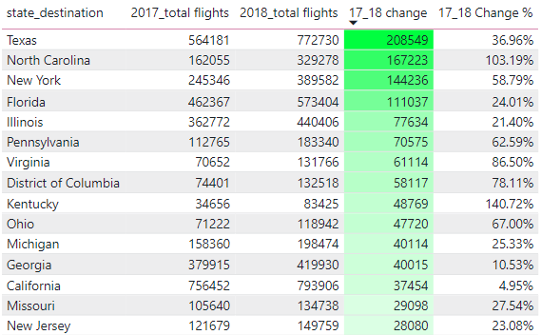

State that gain a lot passenger compared to themselves :

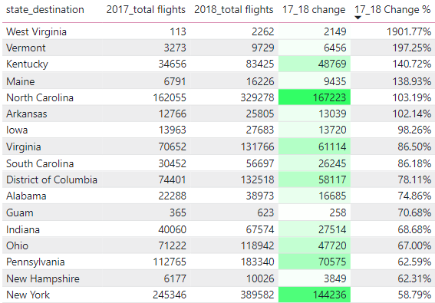

North Carolina appeared 2 times in both tables

Insight: The growth in passenger numbers in states like Texas, North Carolina, and New York highlights a trend of increasing mobility and travel demand in these areas. This could be due to economic growth, tourism promotion, or improved connectivity (e.g., more flight routes). The rise in less populous states suggests a broadening of travel opportunities and potentially underserved markets gaining traction..

### **3.5 Passenger growth in detail :**

Midwest :

* Texas - 52% (71k - 108k)
* New York - 84% ( 43k - 80k)
* Illinois - 26% (100k - 130k)
* North Carolina - 120% ( 22k - 48k)
* Florida - 28% ( 68k - 88k)

Northeast :

* New York - 121% (30k - 66k)
* North Carolina - 76% (37k - 65k)
* District of Columbia - 157% (14k - 36k)
* Pennsylvania - 171% (12k - 34k)
* Virginia - 187% (10k - 30k)

Southeast :

* North Carolina - 150% (68k - 172k)
* New York - 58% (108k - 171k)
* Florida - 36% (165k - 225k)
* Texas - 38% ( 157k - 216k)
* Virginia - 112% (27k - 58k)

Southwest :

* Texas - 48% ( 173k - 257k)
* California - 15% (100k - 125k)
* Florida - 23% (57k - 70k)
* Arizona - 33% (30k - 40k)
* Illinois - 24% (38k - 47k)

West :

* Texas - 13% (124k -140k)
* Arizona - 15% ( 85k - 100k)
* California - 2% (465k -475k)
* Colorado - 7.53% ( 99k - 107k)
* Nevada - 6.84% (84k - 90k)

Insight: The relative stability in the West region suggests that it might be reaching a saturation point in terms of passenger capacity. The limited growth could indicate that the region's infrastructure is either well-aligned with demand or that there are constraints preventing further expansion (e.g., limited airport capacity, regulatory restrictions).

### **3.6 Decline in Virgin Islands Travel:**

Observation: The Virgin Islands saw a sharp decline in passenger numbers across all regions in 2018, following a period of growth from 2009 to 2016. This decline was most pronounced in the Midwest and Northeast.   
  
  
  
  
  
  
  
  
  
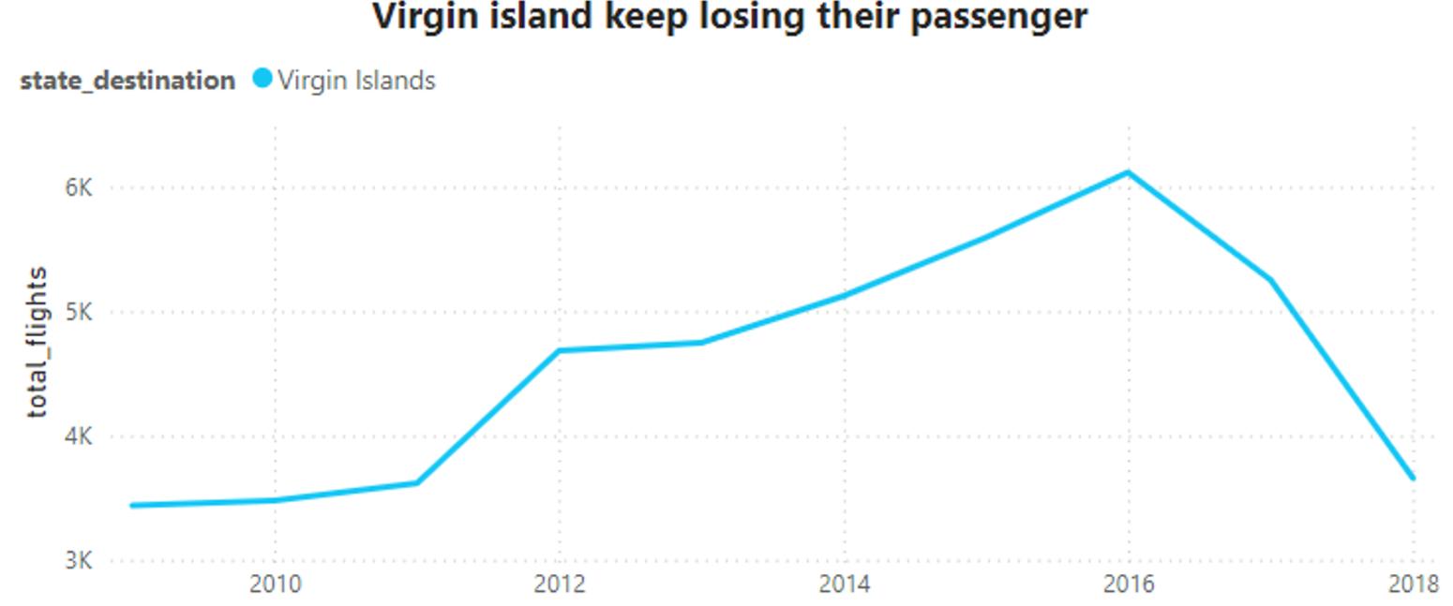

Insight: The decline in travel to the Virgin Islands could be attributed to various factors, such as economic downturns, increased competition from other luxury destinations, or changes in consumer preferences. The trend suggests that the Virgin Islands may need to reassess their tourism strategies to maintain their appeal to high-luxury travelers.

### Recommendations Airlines and Tourism company:

* Northeast-Southeast Connectivity next step :
* Airlines should conduct surveys or reviews on passengers that fly from Northeast to Southeast (especially Georgia, North Carolina and Florida) to know their purposes, their satisfaction with the flight’s experience.
* Emerging Markets next step :   
  + Airlines and tourism boards should pay attention to the rising demand in states like North Carolina, Texas, and New York.
* Finding the reason that makes these states become the hotspots of the year by conducting surveys.
* Cooperate with tourism boards to know which certain places in these states are hot.
* Looking for similar opportunites of hotspots in other regions to prepare for the next year.
* The Virgin Islands' next step :
* Conducting surveys about customer opinion to Virgin Island, to know the reason why they aren’t finding it appealing anymore.
* Reviewing tourism strategies.
* Creating marketing campaigns to reignite interest among previous high-luxury travelers. P
* Partnerships with airlines to offer package deals or promotion.

## 4. Expressjet airline’s problem (EV)

### **4.1 Rapid Growth and Sudden Decline in Total Flights:**

Observation: ExpressJet Airlines experienced significant growth in total flights from 2009 to 2013, peaking in 2012-2013, but then saw a steady decline from 2014 to 2018.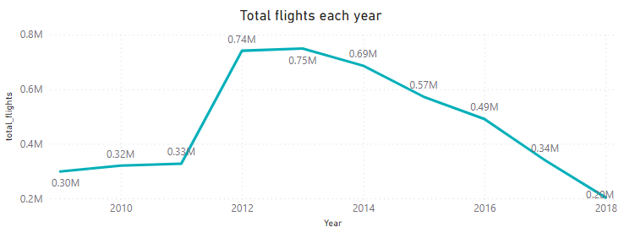

Insight: The initial surge could be attributed to market expansion and strategic partnerships or acquisitions, such as the merger with Atlantic Southeast Airlines in 2010. However, the decline post-2013 suggests operational challenges, possibly due to financial constraints, reduced demand, or competition.

### **4.2 Average Delay Time Increases Due to Carrier-Related Issues:**

Observation : Average delay times due to carrier-related issues increased gradually from 14 minutes in 2009 to 21.65 minutes in 2015 and jumped to around 30 minutes in recent years. For bigger brands, this issue seems to be stable or decline overtime.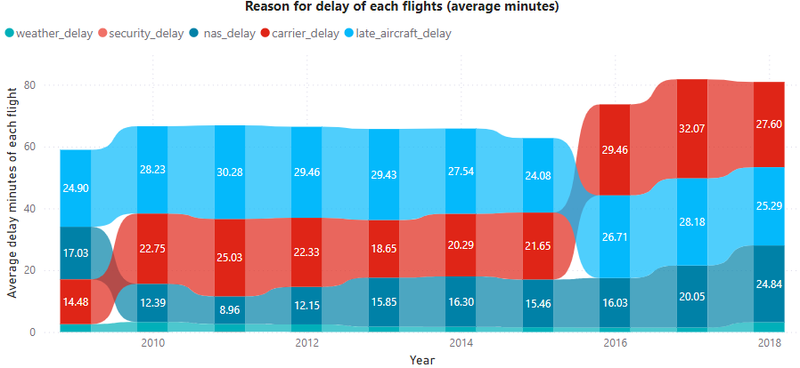

Insight: EV’s ability to control issues related to aircraft’s delay is low since the aging fleet and potential maintenance issues could have contributed to the rising delay times, which may have negatively impacted customer satisfaction and loyalty.

### **4.3 Increased in cancellation and their causes**

Observation: The cancellation rate for ExpressJet Airlines (EV) increased from 2.14% in 2009 to around 3% in 2018, peaking at 5% in 2014.

The primary reasons for cancellations in 2014 were NAS (National Air System) and weather-related issues. In that year, only a few other airlines, like Envoy Air (MQ) and SkyWest Airlines (OO), faced similar challenges with high cancellation rates due to Weather but no airline suffered from NAS as much as EV. Both MQ and OO experienced a decline in total flights in 2015, with MQ ceasing operations temporarily in 2015 before returning in 2018, while OO managed to recover quickly in subsequent years. 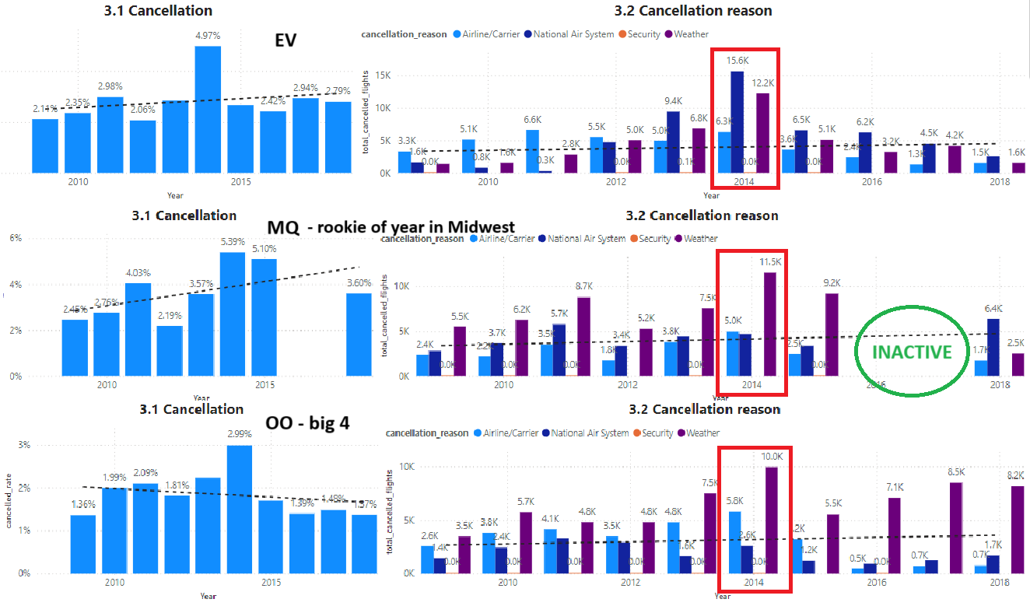

Insight : The significant impact of NAS and weather-related cancellations in 2014 highlights the vulnerability of airlines to external disruptions. However, not all airlines were equally affected, indicating that operational resilience and adaptive strategies play crucial roles in an airline's ability to weather such challenges.

* **ExpressJet's Decline**: EV's high cancellation rate in 2014, combined with its inability to recover quickly, contributed to a steady decline in customer trust and market share. The airline's operational structure may have lacked the flexibility to adapt to the sudden increase in cancellations, exacerbating its struggles in subsequent years.
* **Different Outcomes for MQ and OO**: The contrasting outcomes for MQ and OO underline the importance of how airlines respond to crises. While MQ had to halt operations temporarily and have a great comeback in 2018. OO quickly rebounded, suggesting that OO may have implemented more effective recovery strategies, such as improving operational efficiency, diversifying routes, or investing in better infrastructure to handle disruptions.
* **The ability to recover from disruptions like those experienced in 2014 is critical for an airline's survival and growth.** Airlines that can swiftly adapt their operations, maintain customer trust, and minimize the impact of cancellations are more likely to recover and even thrive after a crisis. For ExpressJet, the lack of a robust recovery plan after the 2014 cancellations likely accelerated its decline, whereas other airlines that faced similar challenges but adapted quickly were able to bounce back or even grow stronger.

### **4.4 Fleet Management Challenges:**

Observation: EV's fleet size grew from 812 aircraft in 2009 to 2,366 in 2015, then dropped sharply to 1,033 in 2018. The drop suggests financial strain, leading to asset liquidation.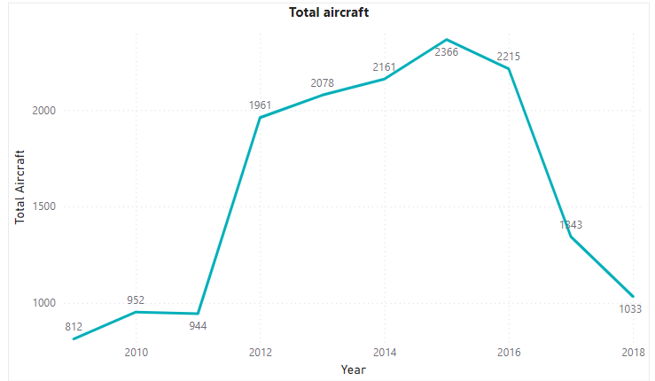

Insight: EV's fleet expansion might have been too aggressive, leading to financial difficulties when market conditions worsened. The sharp reduction in fleet size likely hindered its ability to maintain service levels and contributed to its decline. In 2014, when the crisis started to happen, they were even likely to buy more aircraft, maybe because they think that it will address the issue of total flight decrease.

### **4.5 Shift in Key Flight Paths:**

**Observation:** EV's most significant route, Southeast → Southeast, which accounted for 40% of its flights from 2009-2013, saw a dramatic 60% reduction in the 2014-2018 period. This reduction was consistent across key states like Georgia and Florida.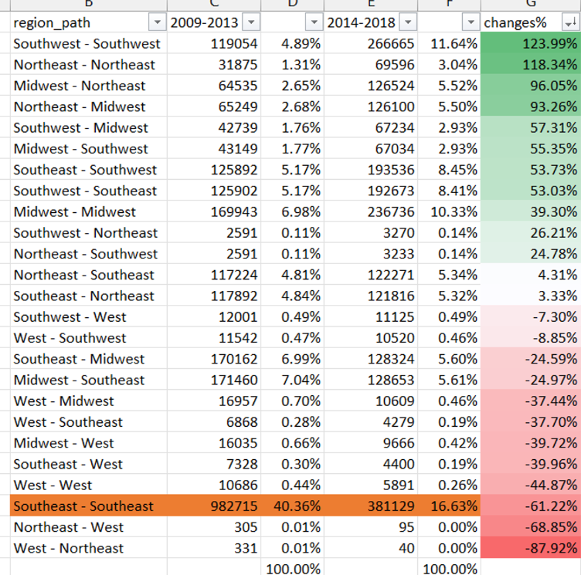

**Insight:** The drastic decline in a crucial flight path indicates that EV may have lost its competitive edge in its core market. This loss of market share in its strongest region likely accelerated its overall decline.

### 

### **Recommendation** Expressjet Airlines**:**

* For EV, they should gather data about their aircraft status to know the reason why delays due to aircraft keep increasing each year.
* EV and other airlines can also conduct an OO strategy to know what did they do that allows them to bounce back even though they suffered high cancellation in 2014.
* Analyzing on MQ previous and after their inactive time to know what have they changed that makes them one of the best rookie.
* EV should conduct surveys on Southeast, West people to know why they did not choose them anymore, especially people that fly local flights in Southeast.
* The EV customer market for flights in Southwest, Northeast and Midwest have grown a lot. This could be the proof that their strategy in these regions is working.